Final Project Report

Beyond the Valley Tourism Management System



Project Supervisor

Sumbal Javaid

Submitted By

Nadia Urooj
S2306B7ED1
(BC200205059)

Software Projects & Research Section,
Department of Computer Sciences,
Virtual University of Pakistan


CERTIFICATE

This is to certify that Nadia Urooj (BC200205059) has worked on and completed his Software Project at Software & Research Projects Section, Department of Computer Sciences, Virtual University of Pakistan in partial fulfillment of the requirement for the degree of BS in Software Engineering under my guidance and supervision.

In our opinion, it is satisfactory and up to the mark and therefore fulfills the requirements of BS in Computer Sciences.

Supervisor / Internal Examiner

Sumbal Javaid
Supervisor,
Software Projects & Research Section,
Department of Computer Sciences
Virtual University of Pakistan

___________________
(Signature)

External Examiner/Subject Specialist

___________________
(Signature)
Accepted By:
_____________
(For office use)

EXORDIUM

In the name of Allah, the Compassionate, the Merciful.

Praise be to Allah, Lord of Creation,
The Compassionate, the Merciful,
King of Judgment-day!

You alone we worship, and to You alone we pray for help,
Guide us to the straight path

The path of those who You have favored,

Not of those who have incurred Your wrath,
Nor of those who have gone astray.

DEDICATION

I want to dedicate this project to Virtual University and all the instructors, due to their lectures I am able to make this project, I am also specially dedicating this project to my mentors whose guidance has been the compass steering me through the academic challenges. Your expertise has shaped my understanding and skills.

ACKNOWLEDGEMENT

I am grateful to ALLAH Almighty. The most Gracious, Merciful and beneficent. Who help me in every field of life, by whose grace I have been able to complete this project successfully.

I express my gratitude
To
All the Staff of Virtual University of Pakistan
For their Great Management

I would like to express my special gratitude
To
Ma'am Sumbal Javaid for invaluable guidance and constructive feedback throughout the project.

Special thanks
To
All Great Professors for getting video lectures recorded. They provided us an opportunity to be a student of Highly Qualified and Experienced Teachers.
Virtual University is a blessing
May Allah Bless and Prosper Virtual university and
May Allah Bless and Prosper Pakistan…
PREFACE

This is a final report for my project. It consists of five chapters. The first chapter is named as “Gathering and Analyzing Info”. The introduction, scope, and purpose of the project have been described. Functional requirement use case diagrams and use case scenarios have also been given.

The second chapter is named “Planning the Project”. It describes work plan for the project. It describes different software development methodologies and the methodology that has been chosen for this project.

The third chapter is named as “Designing the Project”. It explains different design diagrams for this project such as sequence diagrams, class diagrams, database diagrams, development diagrams and deployment diagrams etc.

The fourth chapter of this document explains the development plan (Architecture Diagram)

The fifth chapter of final project document explains the deployment plan (Deployment Diagram).
TABLE OF CONTENTS

CHAPTER NO. 1
gathering & Analyzing info 10

1.1 Introduction

1.2 purpose

1.3 scope

1.4 definitions, acronyms and abbreviations

1.5 Project requirements

1.5.1 Functional Requirements

1.5.2 Non-Functional Requirements

1.6 use cases and usage scenarios

1.6.1 Use Case Diagrams

1.6.2 Usage Scenarios

1.7 Development Methodology

1.7.1 Chosen Methodology

1.7.2 Reasons for Chosen Methodology
1.7.2 Work Plan (Gantt Chart)
1.7.2 Project Schedule (Submission Calendar)

CHAPTER NO. 2
DESIGNING the project 17
2.1 Introduction

2.2 purpose

2.3 scope

2.4 definitions, acronyms and abbreviations

2.5 Architectural Representation (Architecture Diagram)

2.6 Dynamic Model: Sequence Diagrams

2.7 Object Model/Logical Model: Class Diagram

2.8 Database Model (Database Diagram)

2.9 Graphical User Interfaces

CHAPTER NO. 2
designing the project 22

2.1 Introduction

2.2 purpose

  - scope

2.4 definitions, acronyms and abbreviations

2.5 Architectural Representation (Architecture Diagram)

  - Dynamic Model: Sequence Diagrams

  - Object Model/Logical Model: Class Diagram

  - Database Model (Database Diagram)

  - Graphical User Interfaces

Chapter no.3
DEvelopment 37
3.1 Development plan (Architecture Diagram)



CHAPTER 1
Gathering & Analyzing Info

1.1 INTRODUCTION

Beyond the Valley Tourism is a user-friendly web application that offers a comprehensive tourism management system. The system includes essential elements such as hotel information, tourism site information, tour agency information, and many more. The system prioritizes security by protecting tourist data and granting access only to authorized individuals. It is a cutting-edge solution that can address tourism management challenges and is accessible to anyone with an internet-connected device.

1.2 PURPOSE

The purpose of the project is to revolutionize the tourism management process by offering an efficient platform for users. With a focus on enhancing the user experience, the system provides in-depth tourist information, facilitates online bookings with secure payment options, and integrates services for easy navigation. The goal is to streamline the entire tourism experience, allowing tourists to plan and book their trips effortlessly. Additionally, the system serves the administrative purpose of efficiently managing tourist information, tracking bookings, and maintaining financial records for improved decision-making and overall tourism service optimization.

1.3 SCOPE

The scope of the "Beyond the Valley Tourism Management System" encompasses the development of a comprehensive web application that centralizes information related to tourist attractions. It includes features such as detailed tourist spot information, integration with Google Maps for services, online booking functionality, and secure payment options through Jazz Cash or Easy Paisa. The system will also facilitate administrative tasks, allowing administrators to add, update, and manage tourist destinations while tracking bookings and financial performance. Overall, the project aims to create a user-friendly platform that simplifies tourism management for both tourists and administrators.

1.4 DEFINITIONS, ACRONYMS AND ABBREVIATIONS

Terms | Description
ERD | Entity Relationship Diagram
UI | User Interface
API | Application Programming Interface
DBMS | Database Management System
GUI | Graphical User Interface
PHP | Hypertext Preprocessor

1.5 Project Requirements

1.5.1 Functional Requirements
Functional requirements specify the behavior of the system, which can be expressed as services, tasks, or functions that the system must perform. In product development, it is useful to distinguish between the baseline functionality necessary for any system to compete in that product domain and features that differentiate the system from competitors’ products and variants in your company’s own product line/family. Features may be additional functionality or differ from the basic functionality along some quality attribute, such as performance or memory utilization.

One strategy for quickly penetrating a market is to produce the core or stripped-down basic product, adding features to variants of the product to be released shortly thereafter. This release strategy is also beneficial in information systems development, staging core functionality for early releases and adding features throughout several subsequent releases.

Tourist Module

1. User Registration
The user will be able to register himself against the specific account just by entering his name and some required detail for further use. One will be able to review his previous activities by logging oneself into the user account. Other features will be accessed without login or with login both.
2. Search for location & hotels
The tourist module will contain information about tourist attractions. Tourists can find the location of a particular destination using Google Maps. A major module of our system in which searching will be done area-wise. To get the room of his choice user will search the hotels, for this purpose Google Maps will be integrated. We will also provide the user with the actual vision of rooms through pictures. He can get help with these pictures to book his room and check whether it is of their standards.
3. Book a Room
The choice will be selected from the list after the search and bookings will be made. After booking, the room will be allocated to the user and the Price will be shown according to choice. Then we will show detailed information about the selected hotel e.g. Location, Images, Price, and other services
4. Make Payment
After booking payments will be made online through Easy Paisa or Jazz Cash. The system will save all the information about tourist attractions in the country, and when the user will choose the destination so we can filter all the tourist spots in that area.

5. Navigating Maps
Our System will have some additional functionality like guiding particular destinations through Google Map Marker by Google Map API integration. There are several other services we are going to provide so we will now implement them one by one.

Administrator Module

• The administrator will add places or other tourist spots.
• Admin will track the bookings of the tourists and maintain financial performance.
• The admin can add new users or update information about tourists.
• Admin will keep maintaining a record of the user.
• Admin will manage the backend database.

1.5.2 Non-Functional Requirements

There are several attributes of the system that can serve as requirements. Required attributes must be specified so that their achievements lead to better performance of the system. These required attributes are also known as quality attributes as they increase the quality of a product.
In our system, we implemented the following quality attributes or non-functional requirements
1. Reliability
It is reliable in this sense that the system will provide privacy by hiding users’ credentials like account details, passwords, card numbers, etc. It also provides ease in the process of selecting rooms by showing real-time pictures of the rooms. It also provides a user-friendly environment to its users by giving an interactive and responsive Graphical User Interface.
2. Privacy and Security
This System should be made in such a way as to ensure the privacy of all the user’s detail like the detail of the trip they join and their accounts detail. The login activity in the system should be very robust in which only the authorized users can view, add, delete, or edit their required information and should be safe without any access to other data.
3. Filtering / Ordering
Filtering is another nonfunctional requirement provided by our system in which users can apply certain filters. Without this feature, our system will work accordingly.
The area being searched by the user will be filtered through advanced filtering in which particular destinations can be ordered by most/less expensive, performance by user reviews, most visited, and latest tourist spots. A list of all the tourist spots in the desired area will be provided to the user through which he can select one of them.

4. Wallet
It will allow users to store and control their online booking information, and if a user has canceled a booking it will save its credit, and the next time user can use it for booking.

1.6 USE CASES AND USAGE SCENARIOS

1.6.1 Use Case Diagrams
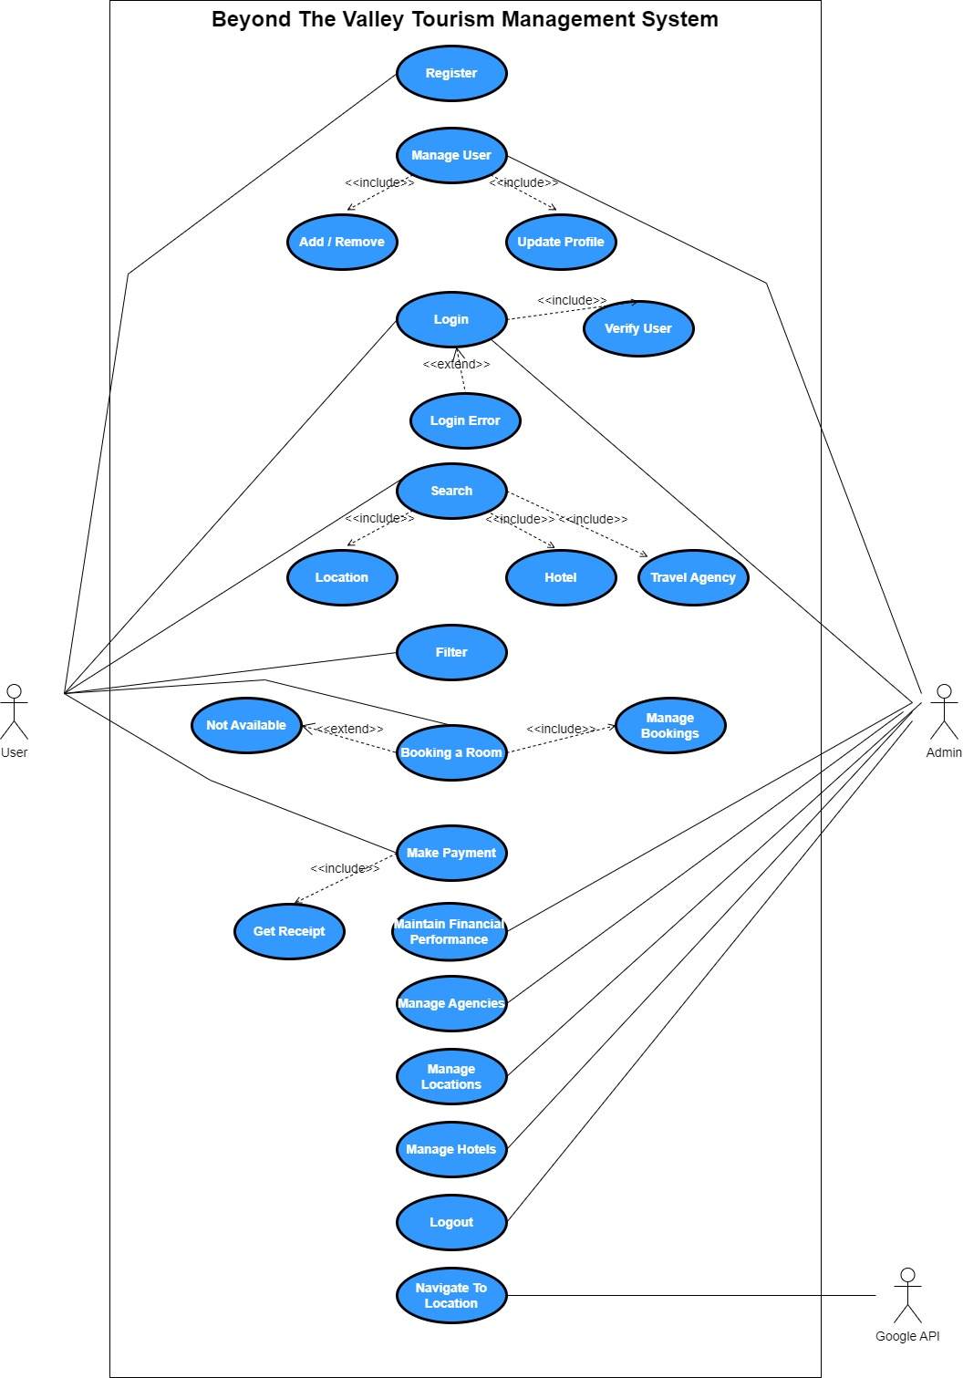

1.6.2 Usage Scenarios

Table: 4.1:
Use Case Title | User Registration
Use Case Id | UC-1
Actor | User
Actions | - Open application.  - Click on Register.  - Fill the form.  - Click OK
Description | This process will register users with their respective usernames and passwords.
Alternative Paths | Redirect to the homepage
Pre-conditions | Must have entered valid information.
Post-conditions | The user has successfully registered.
Exceptions | Invalid information entered
Author | Nadia Urooj (BC200205059)
Modification history | 1.0
Modification date | 25-06-2023

Table: 4.2:
Use Case Title | User Login
Use Case Id | UC-2
Actor | User / Admin
Actions | Enter username and password for login
Description | The system uses a login process that requires users to provide a username and password. Once logged in, users are able to view their respective information.
Alternative Paths | Redirect login path.
Pre-conditions | Must have valid username and password
Post-conditions | The user has successfully logged in.
Exceptions | Incorrect username or password
Author | Nadia Urooj (BC200205059)
Modification history | 1.0
Modification date | 25-06-2023

Table: 4.3:
Use Case Title | Search
Use Case Id | UC-3
Actor | User
Actions | Enter username and password for login
Description | This case will be used to search for the location of a particular destination and book a desired tourist spot by filtering the results
Alternative Paths | Redirect search page.
Pre-conditions | User must entered valid information.
Post-conditions | Users can obtain the location of their desired location.
Exceptions | Invalid strings e.g. sql query injection
Author | Nadia Urooj (BC200205059)
Modification history | 1.0
Modification date | 25-06-2023

Table: 4.4:
Use Case Title | Book
Use Case Id | UC-4
Actor | User
Actions | - Search hotel  - Browse desired hotels  - Select hotel  - Book hotel  - Click Ok
Description | Once the user has registered or logged in, they can then book any available room in the specified hotel.
Alternative Paths | N/A
Pre-conditions | The user must be logged in to book a particular hotel
Post-conditions | Make payments using Easy Paisa or Jazz Cash.
Exceptions | Room is not available
Author | Nadia Urooj (BC200205059)
Modification history | 1.0
Modification date | 25-06-2023

Table: 4.5:
Use Case Title | Make Payment
Use Case Id | UC-5
Actor | User
Actions | - Login into the application.  - Go to the manage hotel section.  - Select particular hotel.  - Go to payment section  - Select payment method  - Fill the personal information  - Click OK
Description | The user will pay for the hotel room after booking it.
Alternative Paths | Payments can be made using Easy Paisa or Jazz Cash. If one is not working then alter the path.
Pre-conditions | Make payments using Easy Paisa or Jazz Cash.
Post-conditions | Payment receipt will be generated
Exceptions | No Balance, Invalid information
Author | Nadia Urooj (BC200205059)
Modification history | 1.0
Modification date | 27-06-2023

Table: 4.6:
Use Case Title | Navigate to Location
Use Case Id | UC-6
Actor | Google Map API
Actions | - Login into the application.  - Go to search  - Navigate to location
Description | The map displays the location of the selected tourist spot.
Alternative Paths | Redirect to search page
Pre-conditions | Search for location
Post-conditions | System will show Google Map and direction towards the selected location.
Exceptions | Invalid location
Author | Nadia Urooj (BC200205059)
Modification history | 1.0
Modification date | 27-06-2023

Table: 4.7:
Use Case Title | Manage User
Use Case Id | UC-7
Actor | Admin
Actions | - Login into the application.  - Go to the manage user section.  - Perform a specific task.
Description | Admin can manage all users. Admin can add, update, and delete any user in the application.
Alternative Paths | N/A
Pre-conditions | Admin must be login into the application.
Post-conditions | According to the specified task, data will be updated into the database.
Exceptions | N/A
Author | Nadia Urooj (BC200205059)
Modification history | 1.0
Modification date | 28-06-2023

Table: 4.8:
Use Case Title | Filter
Use Case Id | UC-8
Actor | User
Actions | - Login into the application.  - Go to the search.  - Click on the filter button to filter the search
Description | It is used to filter hotel to book for the desired tourist area by filtering the results
Alternative Paths | Redirect search page
Pre-conditions | Must have entered valid information.
Post-conditions | User getting list of desired location, hotels and tourist location.
Exceptions | Invalid strings e.g. sql query injection
Author | Nadia Urooj (BC200205059)
Modification history | 1.0
Modification date | 28-06-2023

Table: 4.9:
Use Case Title | Maintain financial performance
Use Case Id | UC-9
Actor | Admin
Actions | - Login into the application.  - Go to the maintain financial performance section
Description | In this case admin maintain the financial performance of user.
Alternative Paths | Redirect search page
Pre-conditions | - Users should be registered on system.  - All required information about the users should be available.
Post-conditions | User getting list of desired location, hotels and tourist location.
Exceptions | Invalid strings e.g. sql query injection
Author | Nadia Urooj (BC200205059)
Modification history | 1.0
Modification date | 30-06-2023

Table: 4.10:
Use Case Title | Manage Agencies
Use Case Id | UC-10
Actor | Admin
Actions | - Login into the application.  - Go to the manage agencies section
Description | Admin can manage all tourist agencies. Admin can add, update, and delete any agency in the application.
Alternative Paths | Redirect application
Pre-conditions | Admin must be login into the application.
Post-conditions | According to the specified task, data will be updated into the database.
Exceptions | N/A
Author | Nadia Urooj (BC200205059)
Modification history | 1.0
Modification date | 30-06-2023

Table: 4.11:
Use Case Title | Manage Hotel
Use Case Id | UC-11
Actor | Admin
Actions | - Login into the application.  - Go to the manage hotel section
Description | Admin can manage all hotels. Admin can add, update, and delete any hotel in the application.
Alternative Paths | Redirect application
Pre-conditions | Admin must be login into the application.
Post-conditions | According to the specified task, data will be updated into the database.
Exceptions | N/A
Author | Nadia Urooj (BC200205059)
Modification history | 1.0
Modification date | 02-07-2023

Table: 4.12:
Use Case Title | Log out
Use Case Id | UC-12
Actor | Admin, User
Actions | Press Logout Button.
Description | Admin and user can logout from the application.
Alternative Paths | Redirect application
Pre-conditions | Admin must be login into the application.
Post-conditions | Sessions will be destroyed and member redirected to the login page.
Exceptions | N/A
Author | Nadia Urooj (BC200205059)
Modification history | 1.0
Modification date | 02-07-2023

Table: 4.13:
Use Case Title | Navigate to location
Use Case Id | UC-13
Actor | Google Map API
Actions | Browse Map  Search Destination  Click Ok
Description | The map of the desired location of the user.
Alternative Paths | Redirect to search page
Pre-conditions | Search for desired location or tourist spot
Post-conditions | System will show Google map and directions
Exceptions | Invalid location
Author | Nadia Urooj (BC200205059)
Modification history | 1.0
Modification date | 02-07-2023

  - DEVELOPMENT METHODOLOGY

    - Chosen Methodology
There are lot of methodologies existed nowadays and a variety of models are being used by various people according to their need and nature of their work.

The names of some of the famous methodologies are.

1) Water Fall Methodology
2) Crystal Methodology
3) Dynamic Systems Development Model
4) Extreme Programming Methodology
5) Feature Driven Development Methodology
6) Joint Application Development Methodology
7) Lean Development Methodology
8) Rapid Application Development Methodology
9) Rational Unified Process Methodology
10) Scrum Methodology
11) Spiral Methodology
12) Agile Software Development Methodology
According to the recommendation, we are going to implement the methodology named, “VU Process Model” its blend of waterfall methodology and spiral methodology. It’s also called hybrid approach of system development.

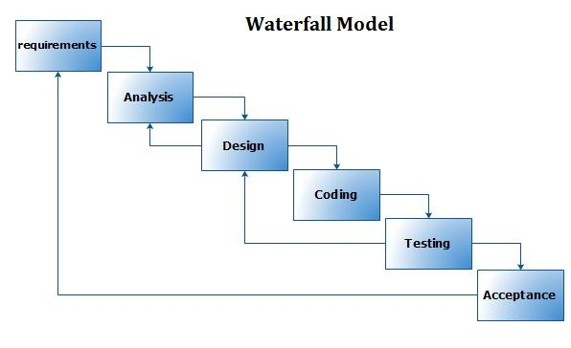
Fig 5.1

The waterfall is a sequential project management methodology in which a project is divided into distinct phases. Each phase begins only after the previous step is completed.

1 Requirements:
This is the initial planning process in which the team gathers as much information as possible to ensure a successful project. The requirement process is a crucial part of the waterfall model and because of that, most of the project timeline is often spent planning.

2 Analysis:
Analysis phase is also known as software requirement specifications (SRS) which is a complete description of the behavior of the software which is going to be developed. This phase wants business analyst to define both functional and non-functional requirements.

3 Design:
In a software development process, the design phase is when the project team specifies what hardware the team will be using, and other detailed information such as programming languages and user interface.
The system design phase has two steps: the high-level design phase and the low-level design phase. The high-level design phase is the skeleton, and the low-level design phase is the organs of the project.

4 Coding:
This is the stage where everything is put into action. Based on the requirements document in step one and the analysis in step two and system design process in the step three the team begins the full development process to build the software using computer languages like C++, C#, PHP etc.

5 Testing:
This is the stage in which the development team hands the project over to the quality assurance testing team. QA testers search for any bugs or errors that need to be fixed before the project is deployed.

6 Acceptance:
For development projects, this is the stage in which the software is deployed to the end user.
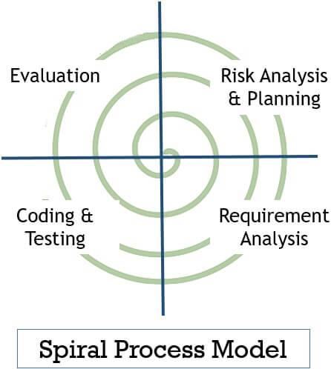

Fig 5.2

It is a risk-driven process model and its most important feature is to decrease the risk of the project.

1 Risk Analysis & Planning:

Developers identify risks involved in the current iteration and also corrective measures to minimize risk. Then they evaluate corrective measures against objectives and constraints. Thus the deadline is set for the next stage.
2 Requirement Analysis:
This phase analyzes the client’s requirements. Also, the requirements for developing the product are also established.
3 Coding & Testing:
Developers develop multiple programs and integrated them to form a software or prototype. Like, in the early cycles the product of this stage would be a prototype. In subsequent cycles, the product of this stage becomes developed software. The product of this stage is tested to find any error in coding.

4 Evaluation:
This stage evaluates whether the project is going as per planning or not. It evaluates whether the objective set at the first stage has been achieved or not. The evaluation phase also helps developers decide the number of cycles required to complete the project.

    - Reasons for Chosen Methodology

Following are some reasons of choosing a mix of both these models:

- The Waterfall methodology is strictly in order which does not permit any development out of order.
- Any change later in the project is not possible.
- Spiral Model is an extension of waterfall model. According to my opinion, Spiral Model is the right model for this project. So if we mix both models it will be easy for the project.
- Sample of the project can be developing in which, potential and flaws of the design might be tested.
- Addition of waterfall model will make the project simple.
- Earlier archetype can build in future.
- Many archetypes can built at the same time.
- Testing is possible with prototypes.
- In vu process model everything is divided in phases to complete the given project.
- All the activities are performed in a sequence in VU Process Model.

    - Work Plan (Gantt Chart)
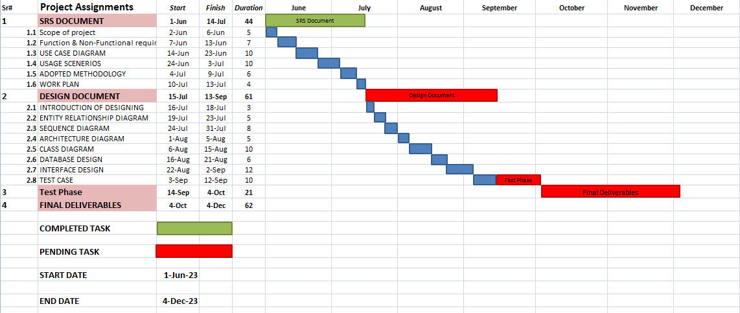

    - Project Schedule (Submission Calendar)

CHAPTER 2
Designing The Project

2.1 INTRODUCTION

The purpose and the benefits of “Planning the project” in software development process is that it gives us a solid understanding of all possible functionalities of our project. And in the result, we can start implementation of our project with more confidence.

2.2 Purpose

The purpose of designing the project is to lay the foundation for successful implementation. It involves creating a blueprint that guides the development team in building a user-friendly, efficient, and secure tourism management system. Designing encompasses visual aesthetics, user interactions, and database organization, ensuring that the final product meets both user and administrative needs while providing a roadmap for the development phase.

2.3 Scope

The project design phase outlines the structural and functional elements of the "Beyond the Valley Tourism Management System." This includes defining the user interface, database structure, and overall system architecture. It identifies the components and interactions required for seamless functionality, ensuring a clear roadmap for development.

2.4 Definitions, acronyms and abbreviation

Terms | Description
ERD | Entity Relationship Diagram
UI | User Interface
API | Application Programming Interface
DBMS | Database Management System
GUI | Graphical User Interface
PHP | Hypertext Preprocessor

2.5 Architectural Representation (Architecture Diagram)
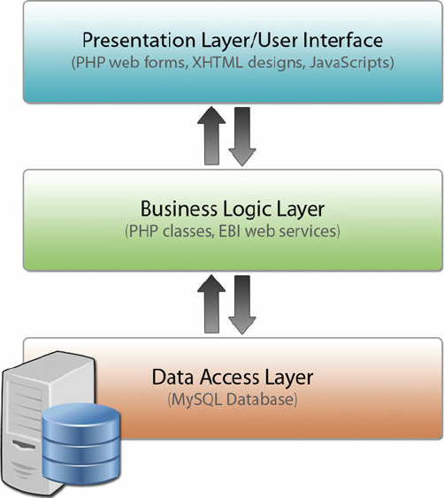

  - Dynamic Model: Sequence Diagrams

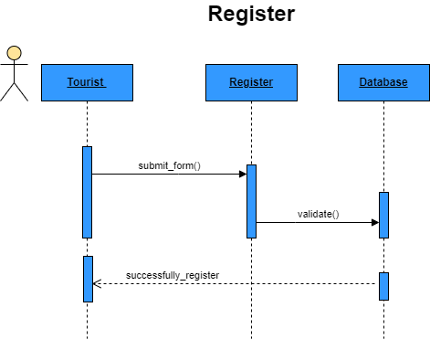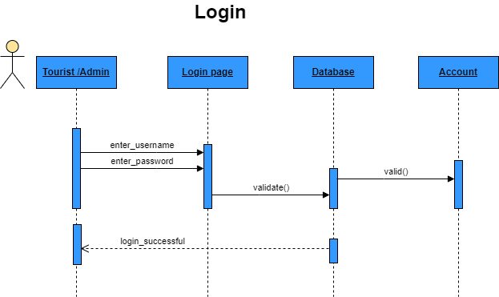
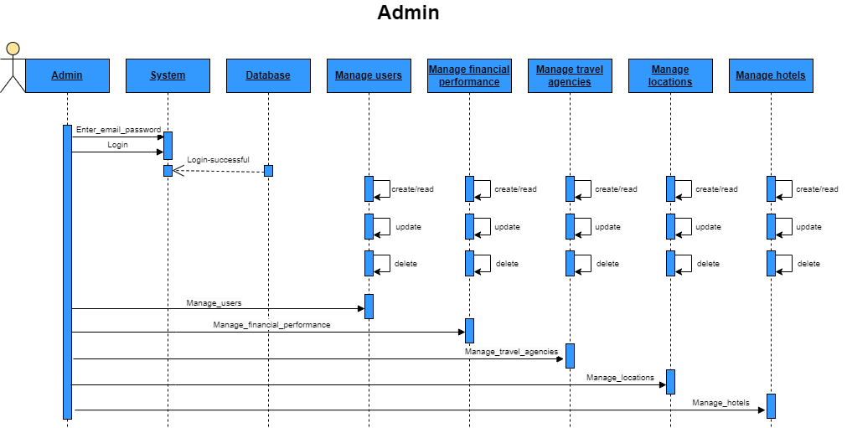
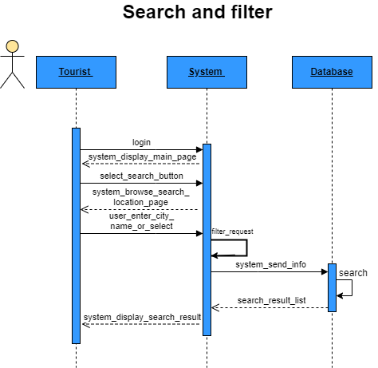
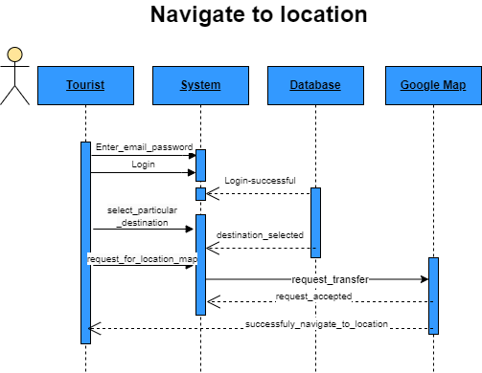
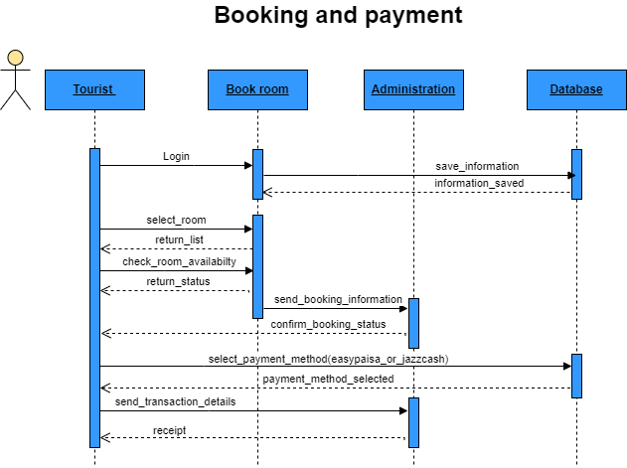
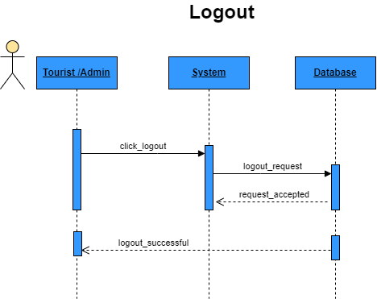
  - Object Model/Logical Model: Class Diagram

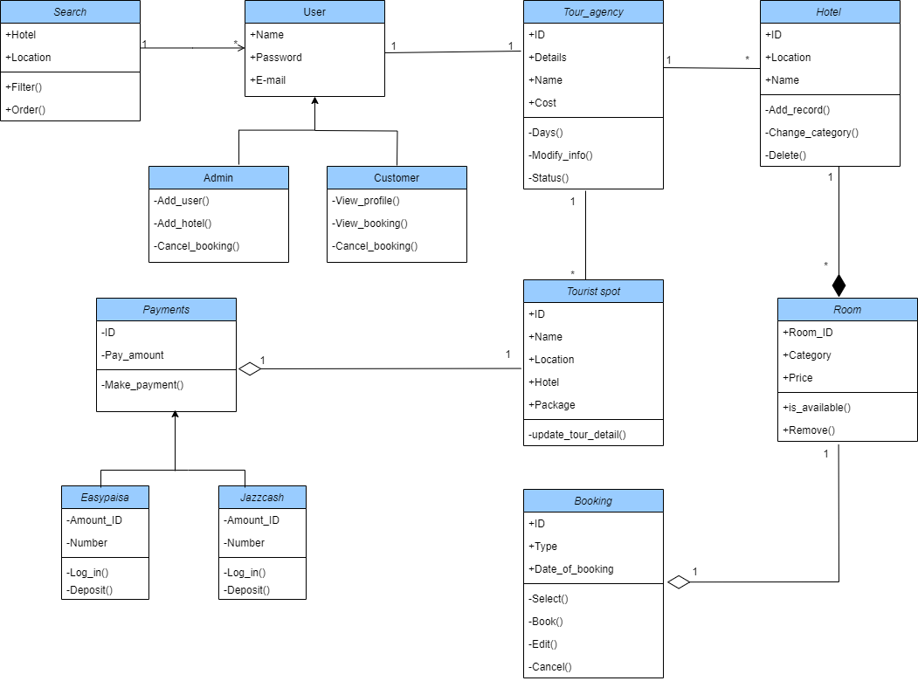
  - Database Model (Database Diagram)
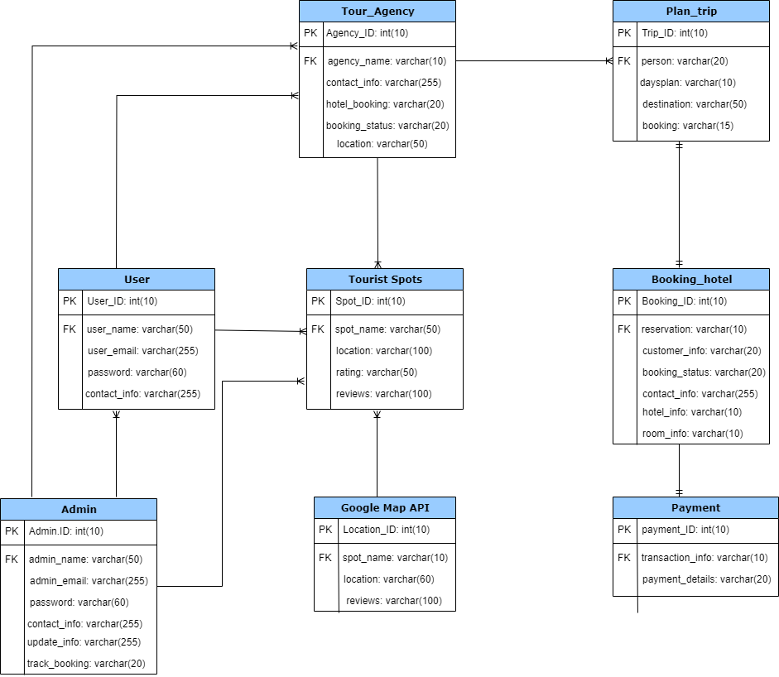
  - Graphical User Interfaces

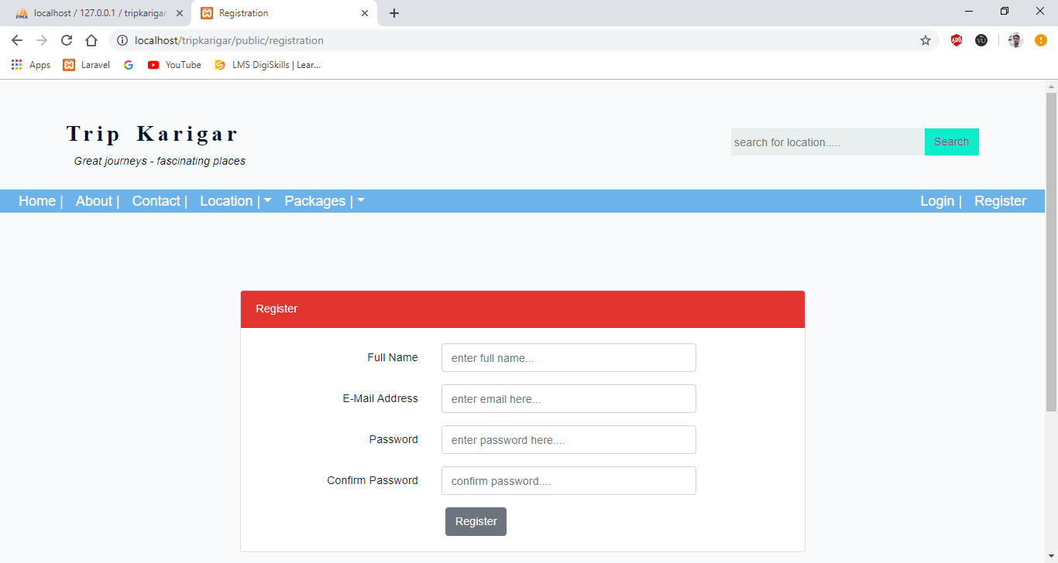

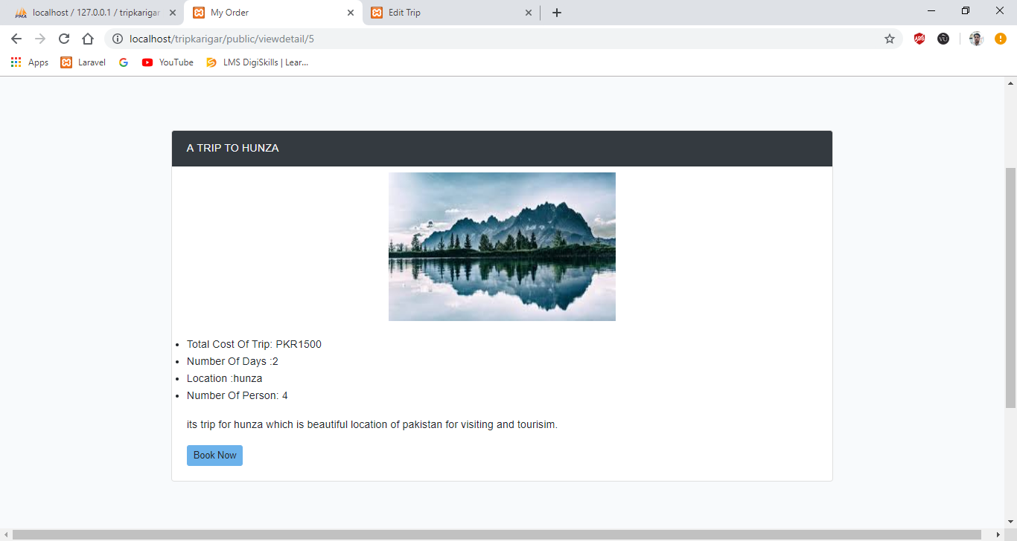
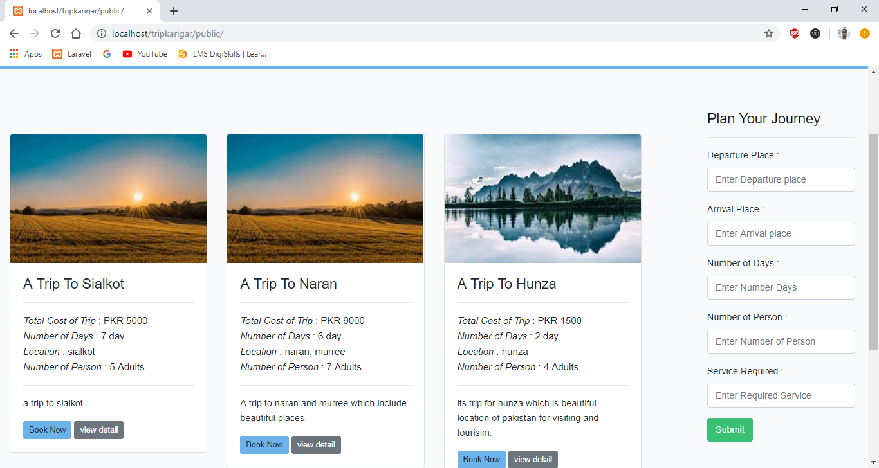

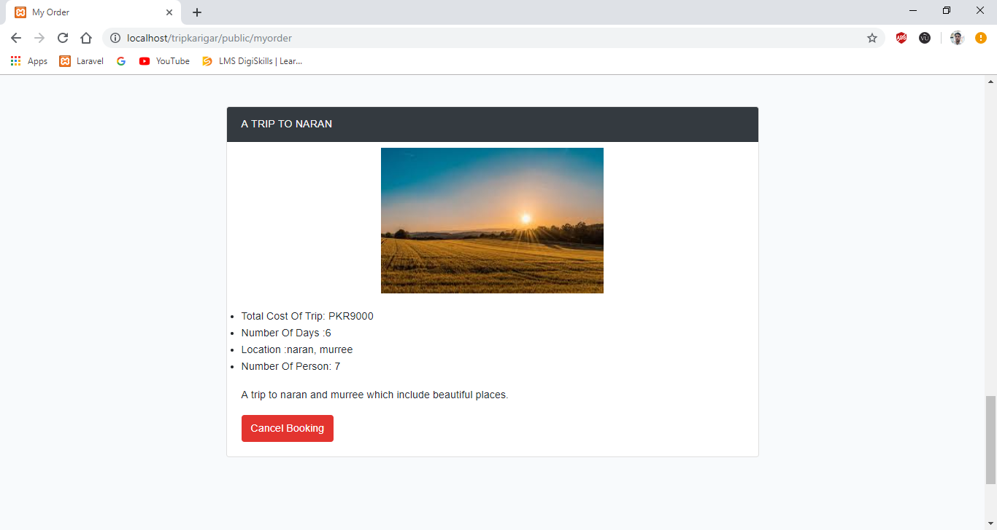

CHAPTER 3
Development

4.1 DEVELOPMENT PLAN (ARCHITECTURE DIAGRAM)

REFERENCES

Websites
www.google.com
www.youtube.com
www.w3schools.com

APPENDIX

Section 1 GATHERING & ANALYZING INFO

Section 2 DESIGNING THE PROJECT

Section 3 DEVELOPMENTS

